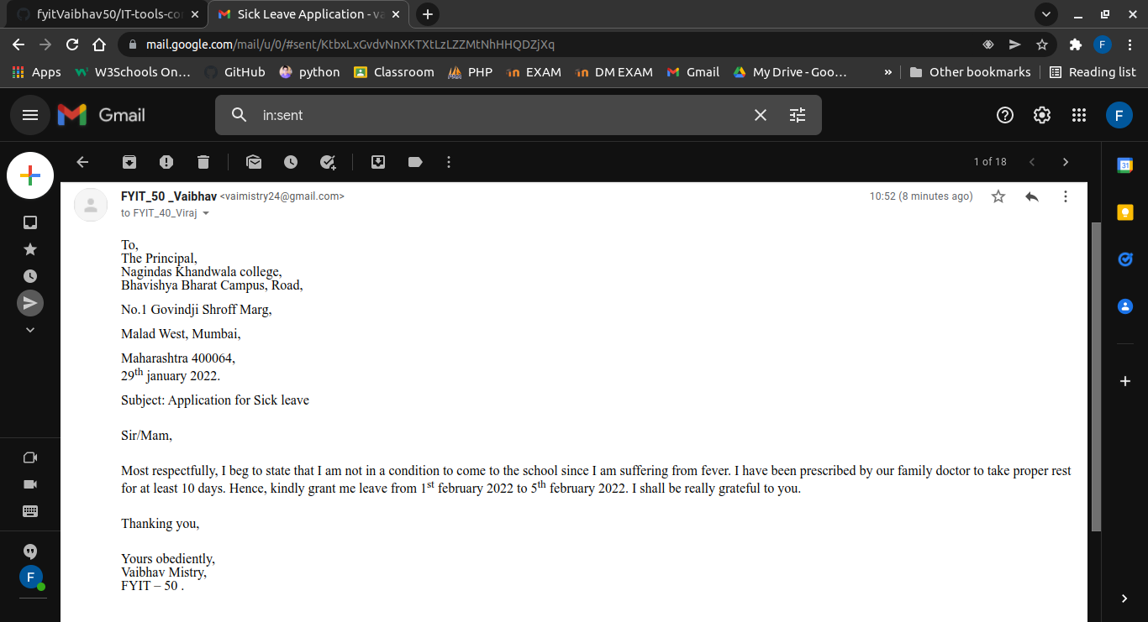**SICK LEAVE APPLICATION**